Computing Science Project

SCN:141881329

Jessica McClure

**Abstract** **4**

**Analysis** **5**

Project Proposal 5

Feasibility Study 7

Environmental Concerns 8

Computing Research on Existing Products 9

Model UN App 9

wxMUN 10

Tikara 11

Survey Questions 12

Selection Strategies 22

Writing Tools 22

Programming Language 22

Programming Environment 24

Database 25

Scope 27

Boundaries 27

User Requirements 27

Chairs 27

Schools 28

Functional Requirements 28

Resources 29

Software 29

Hardware 29

Inputs 29

Outputs 30

Initial Test Plan 31

**Design** **33**

Wireframes 33

Home page 35

Login 36

Voting 38

Results 41

Persona 42

Scenarios 42

Login Delegates 42

Login Chairs 43

Vote on delegates 43

Timer 43

View Results Delegates 43

View Results Chairs 44

User Centric Design - Use Case Diagrams 45

Class Diagram 46

Conceptual Model 47

Login 47

Display 47

Voting 48

Results 48

Sequence Diagram 49

Login 49

Display 50

Voting 51

Results 52

Data Dictionary 53

Entity Relationship Diagram 56

**Implementation** **59**

Database 59

SQL Statements To Create Table 59

Java 60

Connection 60

**Testing** **64**

Home Page 64

Login Page 65

**References** **71**

# Abstract

This application is based around the extra-curricular club of Model United Nations(MUN). MUN is a club which is supposed to replicate the workings of the United Nations. This club allows people to represent a country and debate topics on various issues and create resolutions to solve and tackle the problems presented.

In the United Nations there are many different sub-branches called committee’s. Take for example the well known Human Rights Committee. This committee is most well known for creating the *Declarations of Human Rights* and *The Geneva Conventions*. In my application the committee’s which are at the conference is Disarmament, Economic And Social Committee, Environment and Security Council.

Each committee can have multiple Chairmen called chairs. The chairs job is to mediate the debate and ensure a good structure to the debate.

Each committee will have a representative from a country. This representative from that country is called a Delegate.

The country as a whole with all of the members from the different committees is called a delegation.

Below is a diagram showing how the positions interact and come together:

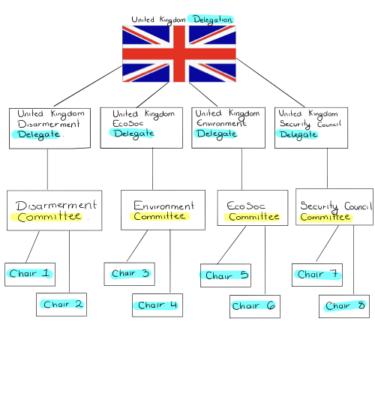

# Analysis

## Project Proposal

I will create an app which will be used in at Model United Nations (MUN) during conferences. This app will be used by the chairs (the people who run the committee sessions) to help for an overall ranking of which delegate should deserve a prize. MUN is a club that is normally targeted at high school or university aged pupils so this will be my target audience. This ranking will be based on a points system in which there will be different categories for the chair to score the delegate who is speaking. All of the different categories will be given a different weight depending on how important it is to the final score. The delegate with the highest overall score will receive the prize of best delegate. Other prizes such as best humor may also be awarded.

Each chair will have the chance to register and login into the app. When the chairs initially register they will state which committee they are chairing for since they can only vote on their committee. The chairs will have access to the voting page and a timer. The chairs will also have access to the overall awards but will only have access to their own committees awards. The delegation will have a chance to register and login into the app. The delegates will not have access to the voting or timer page but will have access to the awards overall and all the committee awards.

There is no current technology like this. The closest thing is a timer for the chairs to make sure the debate is well structured however there is nothing that actually helps in the giving of awards. This is important as it takes away any last minute biased views towards particular countries. This is why another feature that I would add is the ability for a random country to be picked for speaking so chairs aren’t biased towards any particular country.

Delegations will be able to view one of their delegates overall score in committee and the whole delegations combined score. They will not however be able to see the individual scoring on a delegate at a particular time. Total scores will be calculated by adding up the information from all the different voting forms. This information will be held in a database and can only be accessed by the teachers at the school.

My project can be split into four different sections:

1. Login and registration
2. Timer and structure section to put on the board for the chairs to help run the debate.
3. Voting section for the chairs to have on their phone or on a different laptop.
4. Awards and Ranking.

## Feasibility Study

During my project I will have to consider three important factors of feasibility: technical, economical, legal and schedule.

I have access to a laptop in which I can take home which has the appropriate software I would need to complete my program. This software is Netbeans IDE 8.2. I also have enough storage space to run my project. Some of the features however such as the ability to randomly select delegates during the conference if their plaque card is up isn't possible to do with the current technical equipment have access to as this feature would need a camera to interact with the system.

There is no economical benefit or loss in the creation of my project. If my project were to be released then it would require no purchase and would be freeware and therefore would have no financial reward. No money is lost either because all the equipment I required was purchased by the school and so there is no loss to my own budget.

My program will adhere to existing laws. Since information is being stored in a database then one of the main laws of concern is the General Data Protection Regulation however when looking at what information is being stored in thata database none of it is sensitive (the most sensitive information being a username and password to access the program). In the implementation of my program however, if I were to use any parts of code on the internet to help and assist me (such as the building of a timer since this wasn’t included on the silybius) then I would need to make sure to edit the code enough to make it my own and make sure to reference the original creator of the code. If I were not to follow through on that then I would be infringing on *intellectual property rights*. If my idea wasn’t original then I would also be in violation of *intellectual property rights* and perhaps even on the *copyright design and patents act*.

A main concern is the schedule. The project initially started on August the 24th and is due in on April the 17th. This gives about eight months to complete the whole project. However the whole eight months won’t be used in the implementation of the project since all the documentation and testing ect. needs to be completed as well. Due to the time scale that cannot be negotiated there may be features that I can’t include do to the time constraints.

## Environmental Concerns

Not only is there environmental concerns for the use and running of my application but also of the implementation and write up of my project.

MUN conferences last a long time, they usually last a couple days and the voting and timer page will be used almost consistently throughout that day. This means that the program will need to be running constantly and therefore a computer will need to be charged and connected to power. This means that the amount of electricity being used to charge the computer is contributing to the carbon footprint of the machine.

We would suggest that the machines used to run the program would be environmentally friendly by having eco-friendly processors. In 2007 the first environmentally friendly processor was released by intel called the Xeon processing chip which was the first processor which was halogen free.[1] This first environmental processor was released in 2007 and so there has only been environmental advancements in the industry since then.

Although this may not affect my application there are a lot of concept environmentally friendly computer items in which in the future could happen.[2] Solar paneled laptops would be effective in charging computers and therefore the carbon footprint would be dramatically reduced. This being said solar powered laptops wouldn’t be that useful in the concept of my application as most MUN conference take place indoors.

## 

## Computing Research on Existing Products

### Model UN App[3]

This is an app used primarily for the delegates at the conference and not for the chairs. This app also isn’t used for during a conference but just for MUN in general to show useful, basic, information. This app isn’t for my desired audience and isn’t aimed to use during the debate but more for use for research before the conference. 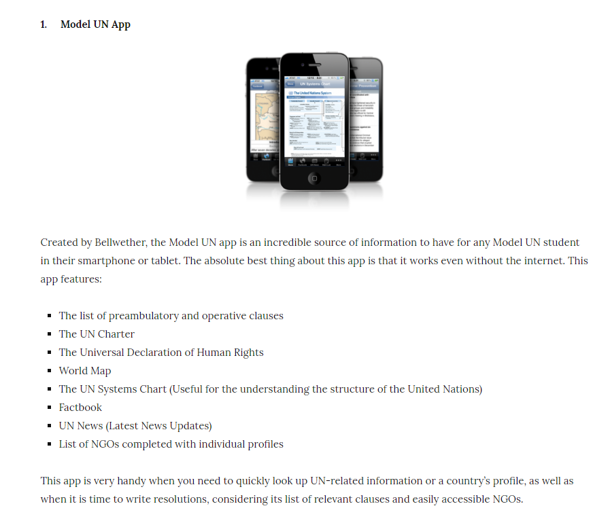

### 

### wxMUN[4]

This app is more for the chairs. This has the use of a timer so that the debate is well structured a feature I would also like to incorporate into my app however it has no scoring system for the chairs. This app shows which committee the app is in use for however this is just typed manually and there is no login to the app. The app can only be used by one chair at the time as well and there is no history features to see what past times have been scored.

This piece of software was used during a previous conference and worked really well. I was initially unsure whether to use my app in correlation with this app or have a seperate section like this in my software. I decided to have a seperate timer section in my app so that the timer results could be stored on the database and used when calculating the total score.

### Tikara[5]

This app has a timer mode for each individual section of the debate and gives you the ability to choose a country. Choosing a country is a feature I would like to incorporate however I would like the timer list to be niche depending on what countries were registered. 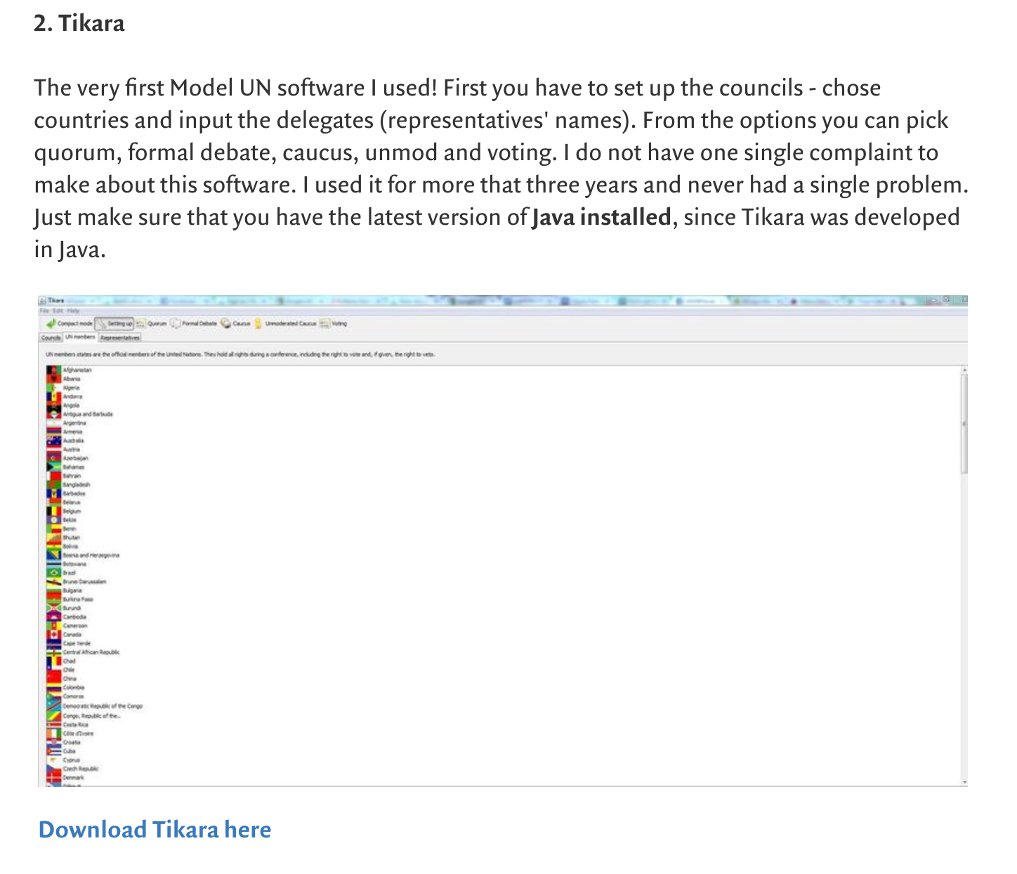

Although I will have a timer included I think this timer would be used all round and wouldn’t be used for individual sections as this would seem to be too much of a hassle for the users.

## Survey Questions

*Only aimed at MUN members who are aware of how a conference works and may have/will have in the near future experience in charing.*

1. How good are you at using technology?

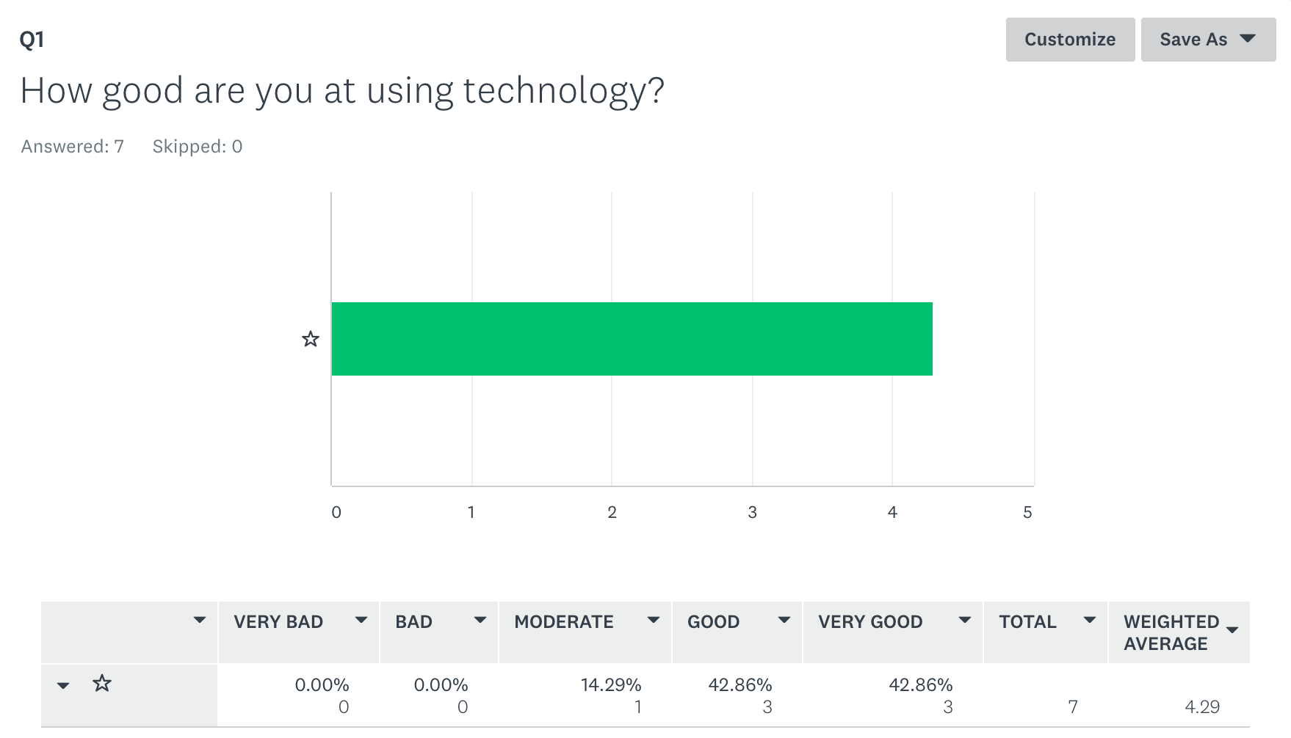

The overall conclusion was that the majority of people felt good and if not very good. Since this application was aimed at high school MUN club members most felt pretty confident in using technology. This was expected. This means that I could perhaps put more complex features in my application however this will probably be unlikely as the simpler the application is the easier it will be to use especially during a debate when the application is used as a tool to make chairing a debate easier. The less concentration it takes to use the application the better.

1. Have you ever chaired a conference or are at a level in which you could chair a conference?

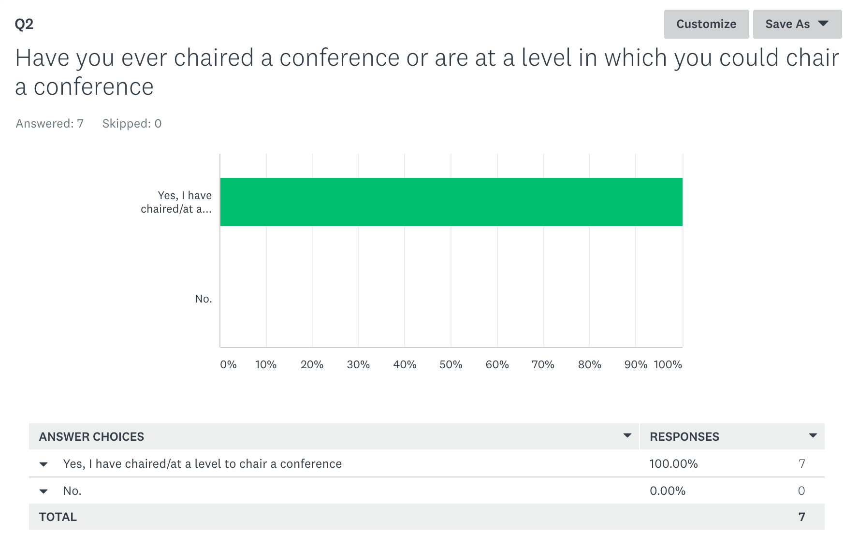

This question was aimed to make sure that the desired audience I would be targeting (potential chairs of debates) were giving informed suggestions on how I could make the application. As seen by the 100% response to ‘I have chaired/ at a level to chair a conference’ the survey went to the desired audience and all of the responses were well informed and all responses should hold value.

1. Have you used a piece of software before when chairing a debate (if so please specify)?

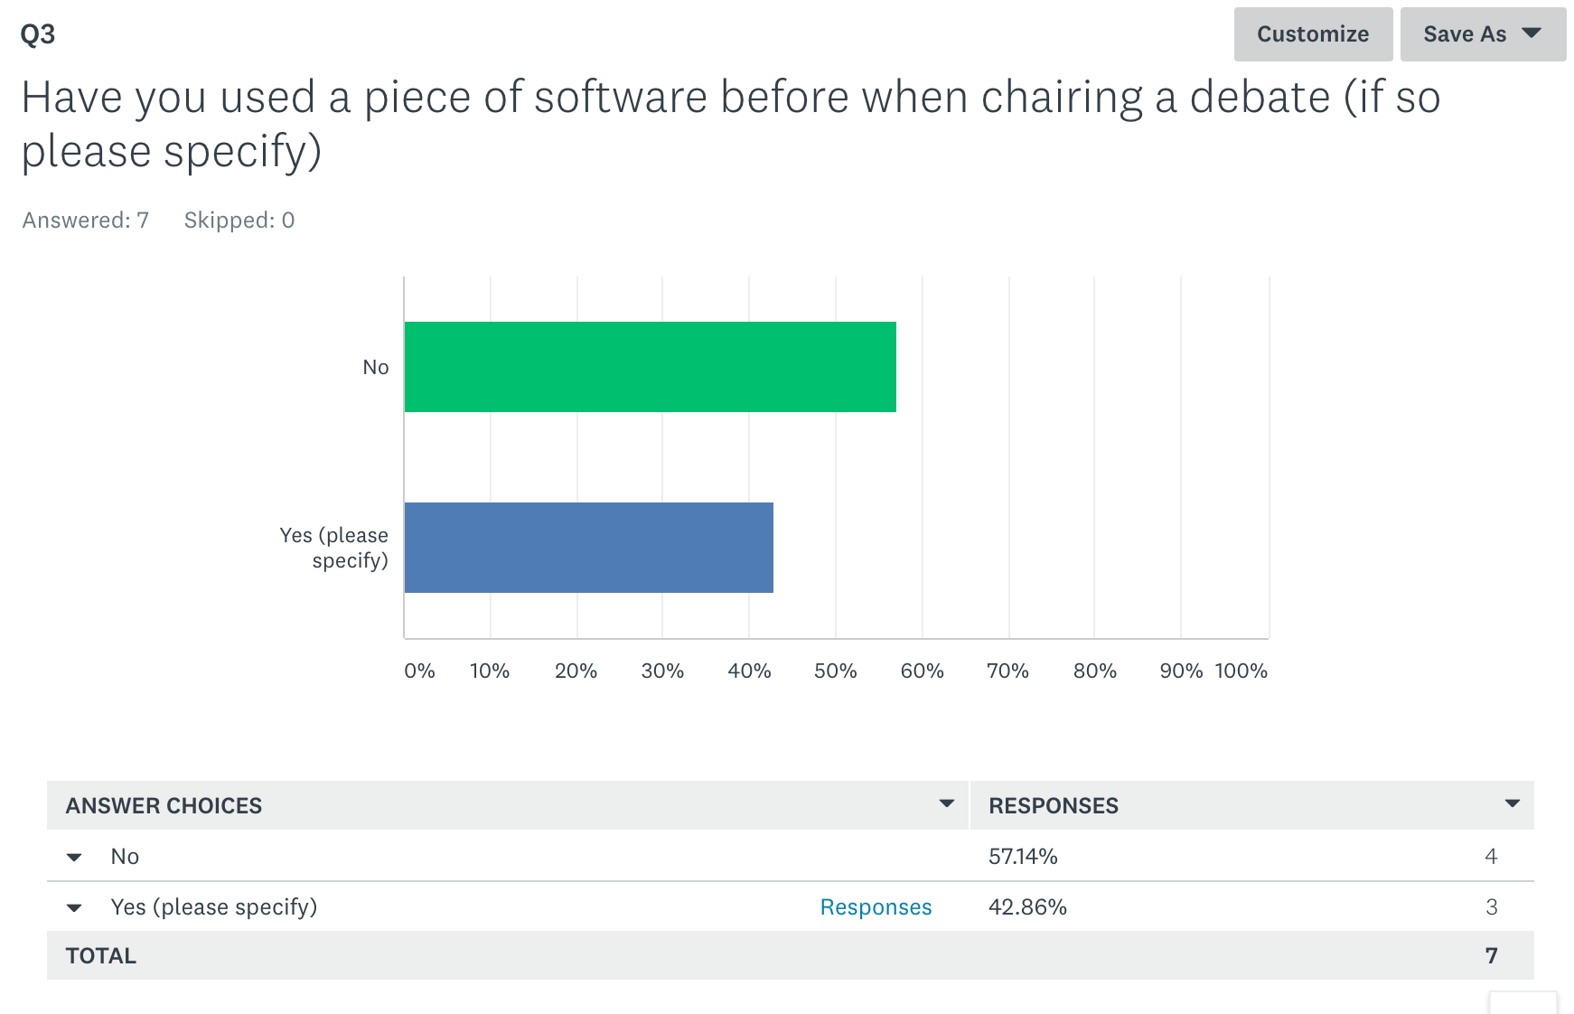

I wanted to see that if I were to make an app whether it would be useful or if the old method of pen and paper would be more used. I was surprised to find out that the amount of people using technology while chairing was only one less than those who haven’t used technology. This was a positive answer as it showed that people would be willing to use and get to learn how to use my application.

The responses that people wrote about technology which they have used was looked at in the ‘research existing technologies’ section.

1. What feature would you find useful in this app (i.e. Timer) ?

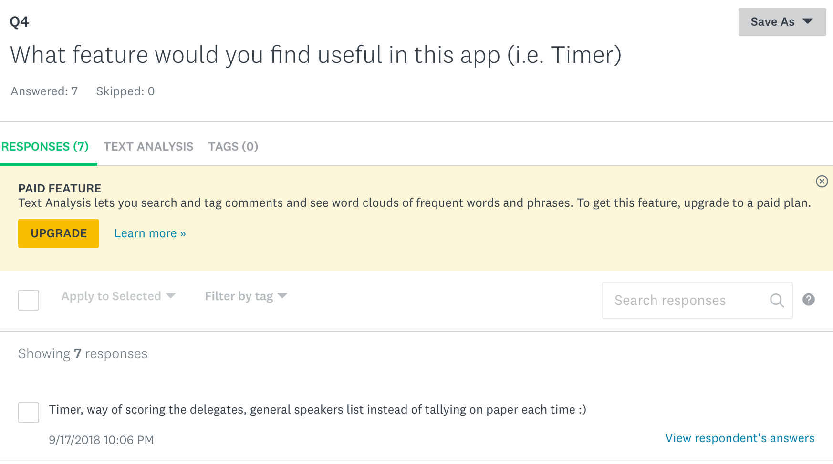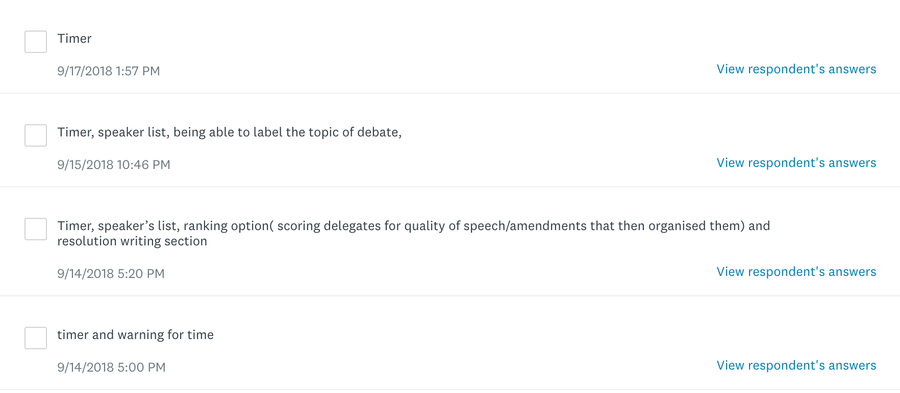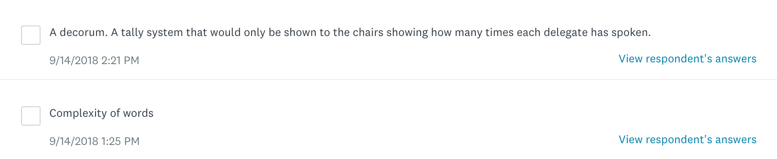

Although I already had my ideas of what features I wanted to include I wanted to know if other people thought the same or had any completely different and thought provoking ideas. Although a couple of responses included the ‘timer’ option (an important feature I wanted to include) I think this was mainly because it was prompted in the question. That being said people did like and agree with the idea.

A suggestion was a ‘speaker list’ this is included in my application in the drop down boxes from the timer and even in the voting page. Although this wasn’t initially part of the design I decided this would be effective and increase the usability of my application.

I haven’t included ‘labelling the topic of debate’ as I didn’t think this was crucial in how my application ran. It would be a slightly unnecessary feature however could still be added in future updates of my app.

The ‘ranking option’ is included in my application as the ranking and sorting of the delegate and delegations total score will be ranked from first to last using a sorting algorithm. The response to the question may have meant that the chair wanted to be able to rank the delegates themselves manually instead of a total score being calculated however this would be defeating one of the main purposes of my app. If the chair was able to rank the delegates after the voting then they providing a biased viewpoint and the whole point of voting was to take away some of that initial biases.

A ‘resolution writing section’ would actually be useful for when the delegates login however considering currently I have a initial delegation login I don’t know how this would be implemented. If I had time at the end however I would like to include a feature like this.

A ‘warning for time’ feature would be very good to include in my timer feature. The colour of the text on the count down could change once the delegate speaking gets to 10 seconds or something along those lines. This will be a feature I would like to include in the timer.

A ‘decorum’ would be useful point to judge on in the voting page however to have a whole section of the app dedicated to decorum seems unnecessary in this initial release of the app.

A ‘tally system’ would be a very useful and good section to have in the app however it might create and cause clutter on the screen and become stressful to use for the chairs. I might try and incorporate a feature like this if I have time at the end.

‘Complexity of words’ would be a good quality to include in the voting sheet however a whole section in the app wouldn’t be useful.

1. Do you find yourself biased toward a particular delegate at a conference?

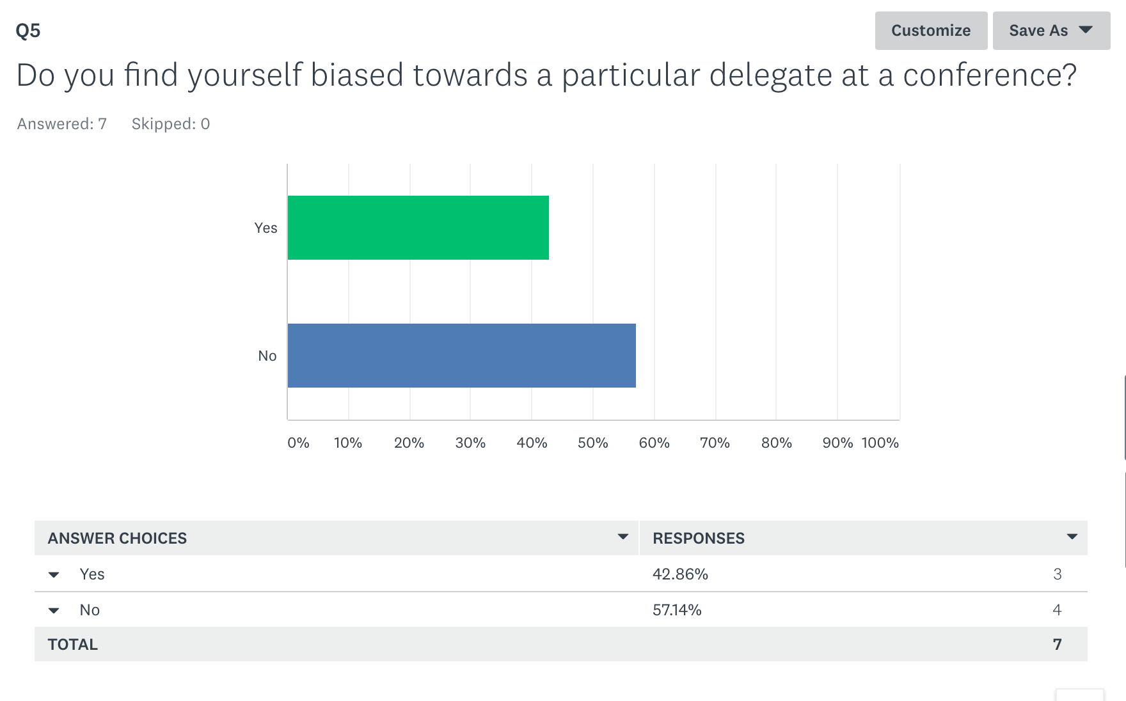

This response was slightly unexpected as I thought that the majority, if not all the people, the response would be that they found themselves biased. This being said the ‘no’ response only gained majority by one more vote so biassed views can still be seen as an issue and so this is still an important feature to include in my app.

1. Would you find it useful for an app or software to randomly select a country (that has there plaque up) to get rid of any bias opinions?

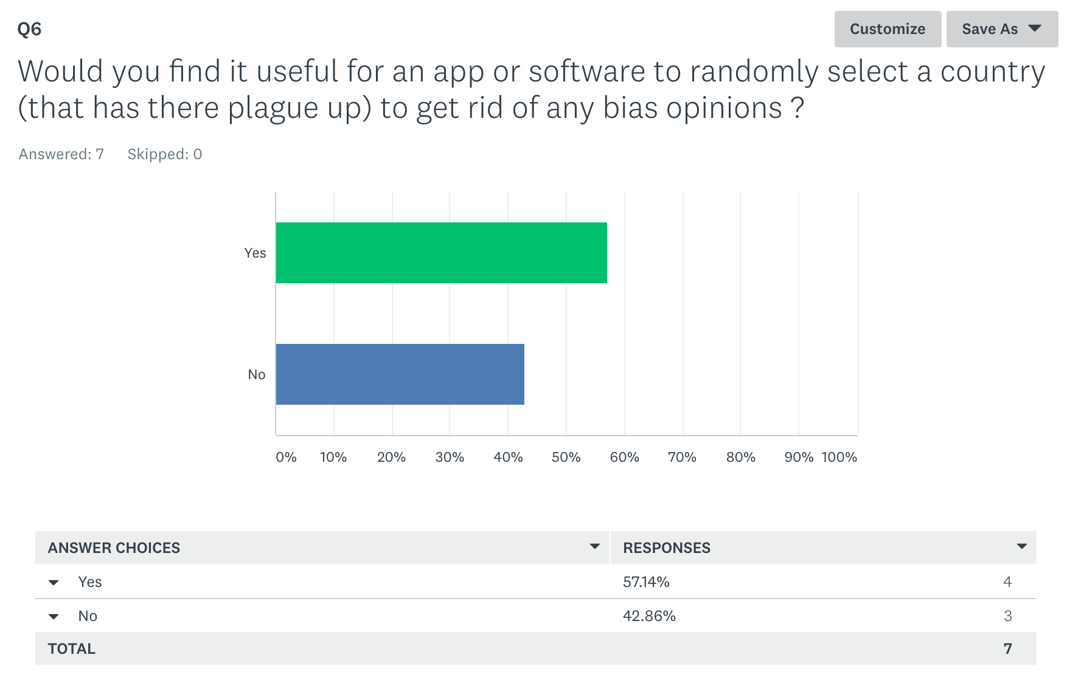

I did pose the question and thought this would be a very good idea at the time however after I started implementation I realised that this wouldn’t be very practical to code or an effective use of the program. Although the thought to randomly select countries is very good to select only countries who have a plaque card raised is very impractical. It would take longer to select which countries have there plaques up than to actually just pick the person. This is why I have decided to drop the feature even after the responses agreed and thought this would be a good idea.

1. Would you find a ranking system useful to help select a delegate for an award?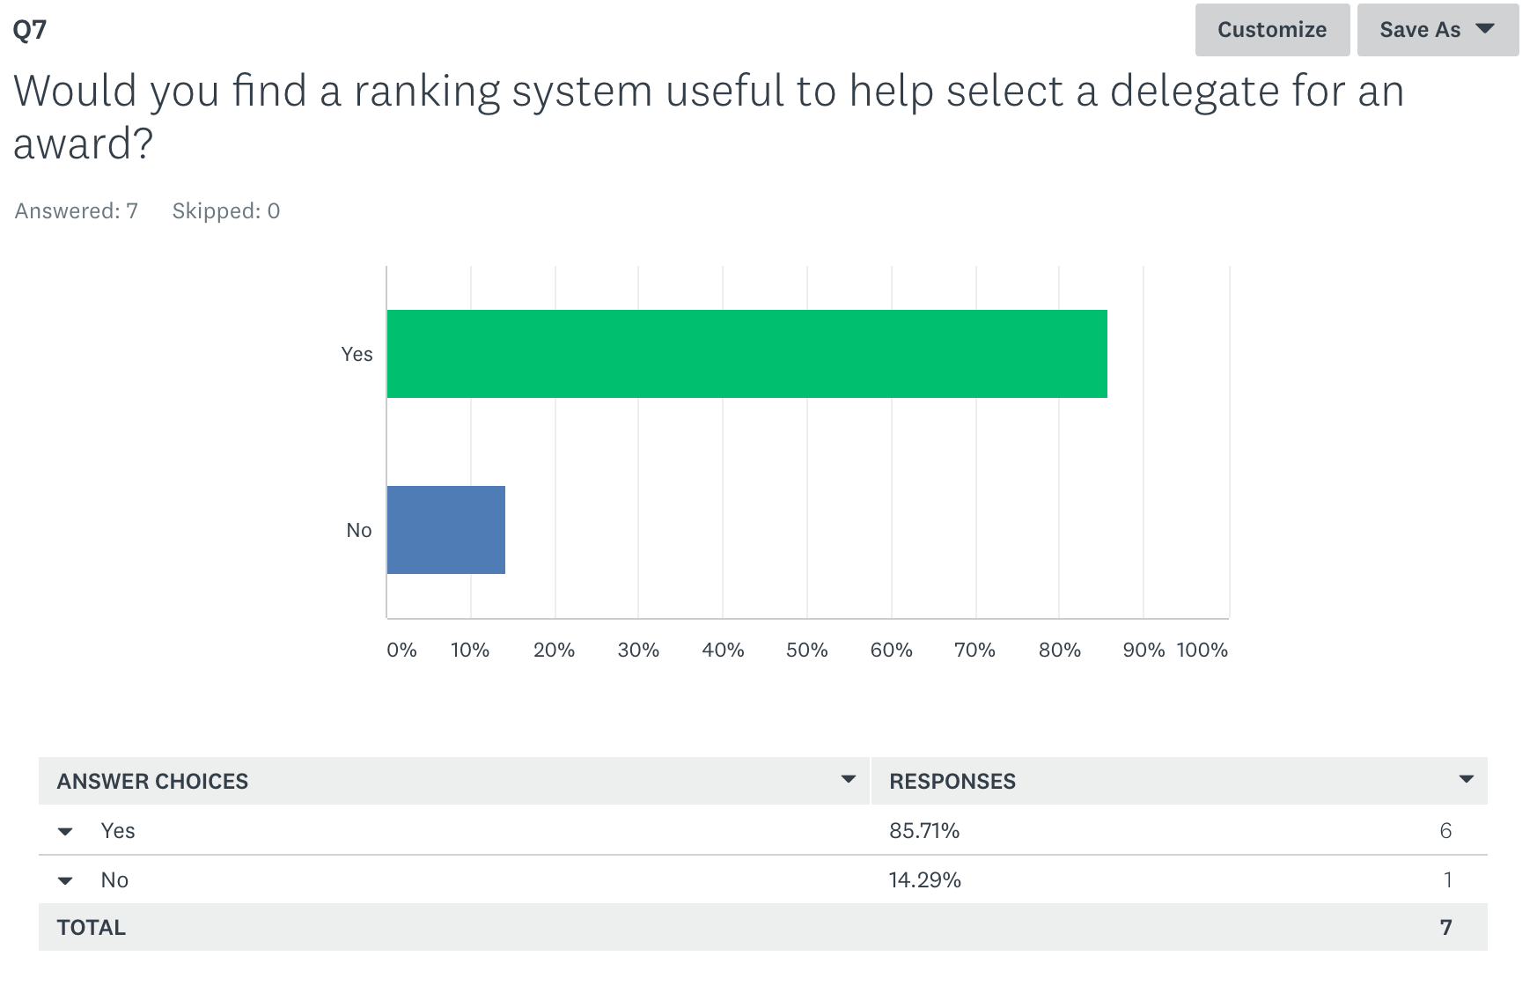

This was an expected response as this is one of the key features of my program. The ranking of delegates will be viewed on a separate page. Awards will be based off of the ranking scores and both the rankings and awards will be displayed.

1. Which qualities do you think should the ranking be based of off?

The main sections that I need to rank off of since there was a 100% agreement that these qualities should be included: ‘Quality of Speech’ and ‘Ability to a handle Point of information’. I will also include ‘humour’ as there will be a ‘Funniest Delegate’ award and therefore this quality will be used to give the award. I also decided to include the suggestion of ‘number of times they have instigated debate’. I decided not to included the engagement in debate as this would be in parallel with the number of records and voting forms submitted. 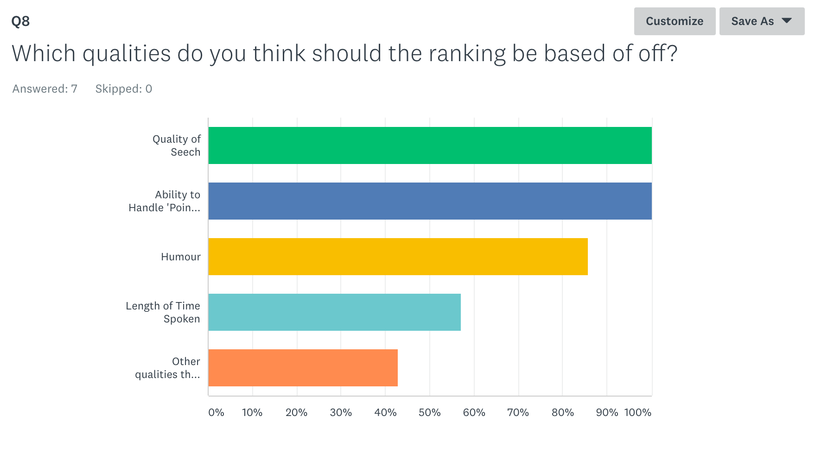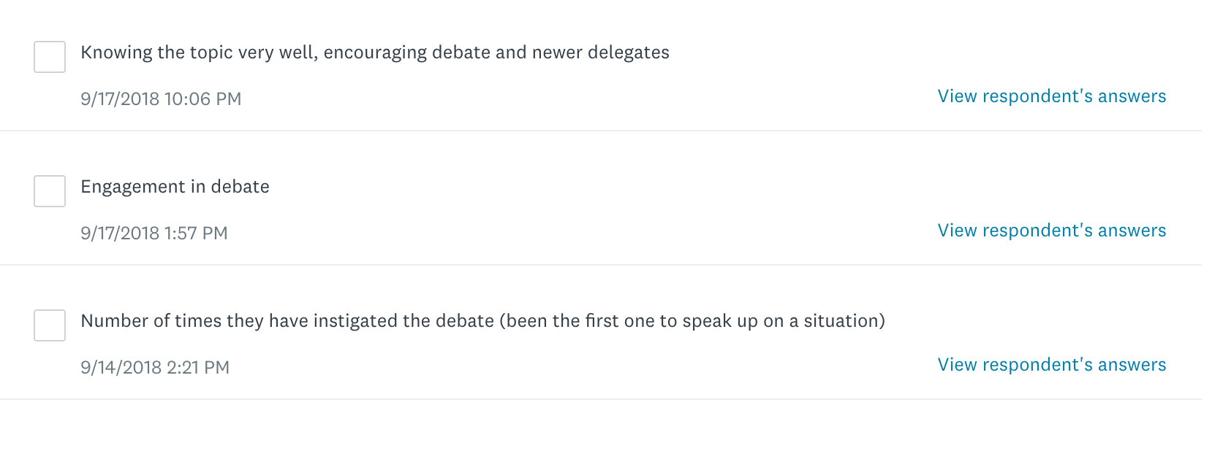

1. Do you think you would find the entering of data during a conference tedious?

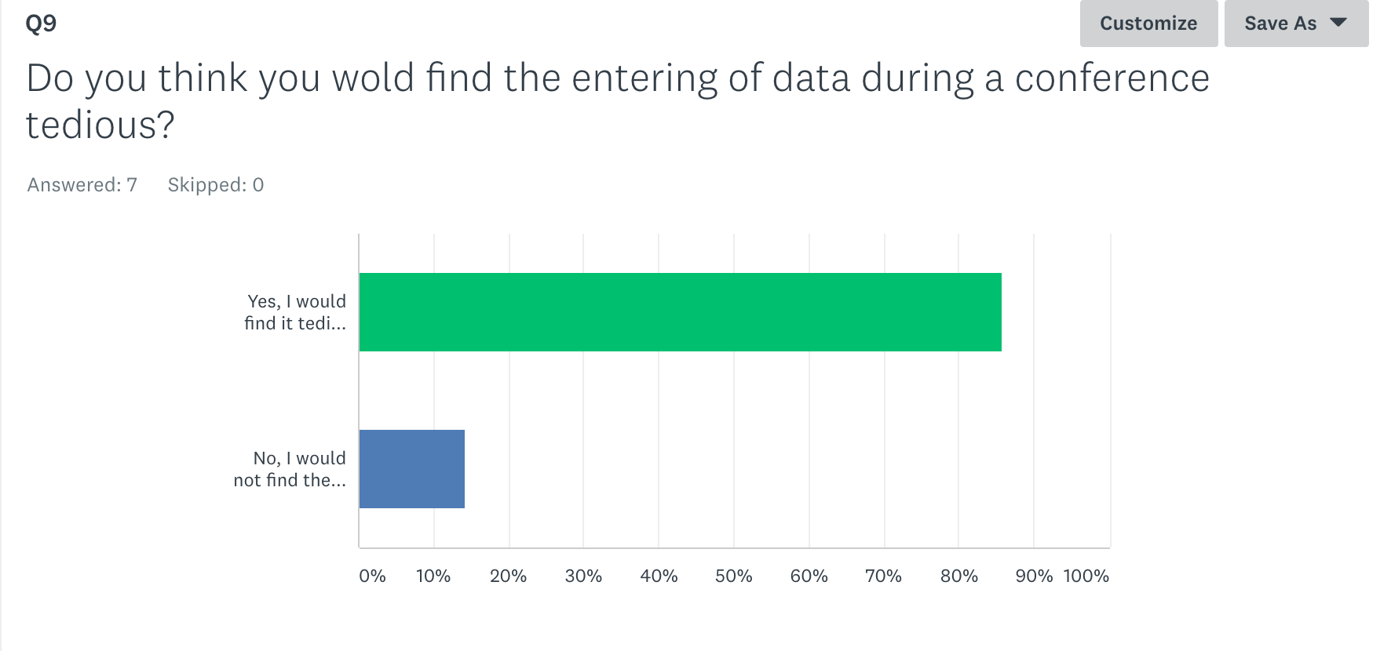

This question was very important because it would determine how often people would use the app. When creating the voting form I need to make sure that the number of clicks and buttons required to submit the form is minimum otherwise the whole process could become annoying and people wouldn’t want to use my system.

## Selection Strategies

### Writing Tools

|  |  |
| --- | --- |
| Name | Microsoft Word |
| Description | This software package is used to write up documents. |
| Advantages | Tools and options to write up report such as the referencing tool as well as the ability to apply footers. |
| Disadvantages | Can’t use cloud computing. |

## 

|  |  |
| --- | --- |
| Name | Google Docs |
| Description | This software package is used to write up documents. |
| Advantages | Cloud Computing therefore it will be easy to continue my work if I am on different computers. |
| Disadvantages | Not as many editing tools such as not being able to apply different footers to the pages. |

I chose to use a combination of both Google Docs and Microsoft Word. I will use Google Docs while editing and creating my report so I can make use of the cloud computing aspect so I can access my report on multiple computers. I will use Microsoft Word before finally printing off my report so that I can make use of the footers and referencing tools.

### Programming Language

|  |  |
| --- | --- |
| Name | Java[6] |
| Description | A high level object-oriented programming language. This language was developed by *Sun Microsystems*. This language is popular for creating web applications. |
| Advantages | Java applications can run on multiple platforms due to the fact that Java programs are interpreted by a Java virtual machine instead of the the java program being run on the computing system.  Object oriented therefore concepts such as classes, objects, inheritance, encapsulation and polymorphism can be used. Modular code can be used to make coding and the running of the program more efficient as well. [7] |
| Disadvantages | More memory consuming and can be slower when compared to other languages such as C or C++. 5 |

### 

|  |  |
| --- | --- |
| Name | Visual Basics |
| Description[8] | This is an event-driven language which is currently in its third generation. This language was created by Microsoft. The program promotes the use of Component Object Model (COM). COM enables inter-process communication object creation. |
| Advantages[9] | Very simple and straightforward syntax and easy to initially understand.  A lot of online help as this is application is made by Microsoft and this is a big company which will provide a lot of online services and support technicians.  Supports the use of Rapid Application Development. |
| Disadvantages[10] | High memory constraints as it is based around a Graphical User Interface development and therefore requires a lot of space to use this preset controls such as textbox.  Not good when you longer applications need to be processed.  Harder to use objects as this isn’t an object-oriented language so you cannot achieve as complex programs. |

I chose to use to use code in Java. This was mainly due to the fact it was an object-oriented programming language compared to Visual Basics which is an event-driven language. In turns of being rapid application development both are pretty similar.

### Programming Environment

|  |  |
| --- | --- |
| Name | Netbeans IDE |
| Description | Software which allows you to program in many different languages such as Java, C++, PHP, Groovy. |
| Advantages[11] | Free and open source software.  Integrated development modules which means there is access to features such as debugging tools.  Includes SWING GUI tools which makes designing an interface very easy.  Auto completion of code which makes coding easier as this gives coders possible endings to their code.  Versioning tool is available which allows for the ability to look at past version of your code and what has been done to change it, what has been edited. |
| Disadvantages10 | Known to take longer to load initially.  Application takes up more storage on memory to install.  Using the advanced tools that are available can require more learning and can be too complicated to use and so the initial advantage of having the advanced tools is lost. |

### 

|  |  |
| --- | --- |
| Name | Visual Studio |
| Description | An environment created by Microsoft. This environment allows you to code in many different languages including languages such as C++, visual basics and C#. |
| Advantages | Has many reviews saying how the environment is easy to use and therefore the environment is very accessible and user-friendly which is good.10  Efficient compilers.  Debugging tools . |
| Disadvantages | Some reviews have reported crashes whenever working on large programs.[12] |

I will use Netbeans IDE to implement my program. Netbeans IDE also allows for the ability to program in Java which was the programming language that I choice. The programming environment is also better when programming larger applications which my program will be and I don’t want to run the risk of my program crashing which is why I will used Netbeans IDE.

### Database

|  |  |
| --- | --- |
| Name | MySQL |
| Description | This is a relational database management system. This is written in a structured query language. |
| Advantages | Free and open source. Quick processing, good reliability, easy and flexible to use. This is a portable system meaning it will run on any operating system. |
| Disadvantages | Difficult to debug as no debugging tools are provided. Difficult to maintain. Not good for complex and flexible business logic. |

### 

|  |  |
| --- | --- |
| Name | Oracle Database |
| Description | Multi-model database management system created by the company, Oracle. This is most commonly written in languages such as C or C++. |
| Advantages | Since produced by the Oracle company there is great customer service if stuck. Used to store complex databases and can be found to be used in banking. High data storage therefore very reliable. |
| Disadvantages | Have to pay for licensing to use the system. Since complicated to use it may be hard to find people who specialize and can manage a database in this language. |

I have chosen to use MySQL. I decided primarily to use this database as I have worked with it before since and am familiar with the environment and the language.

### 

## Scope

My solution will be able to score delegates in there overall performance at a conference. They will then be ranked in their committees and prizes will be awarded accordingly. Prizes such as best delegate, best junior delegate, highly commended and commended will be awarded. The prizes will be given to those in the corresponding ranking position. Ranking will be determined by a delegates overall score. This will be calculated by the chairs scoring (1 to 5) on categories such as humour, quality of speech, ability to handle points of information and length of time spoken. My solution will also incorporate a timer that can be used during committee sessions so that debates run more efficiently. The chairs in the committee will also be able to randomly select countries when selecting who should speak at the front to reduce biasiam.

Another function that my solution will be able to do is that schools can look back on past conferences and see the schools overall score as a whole compared to other schools that attended that conference.

## Boundaries

My solution will not be able to help the delegates at the conference and will only be used by the chairs. Delegates will have a login however they will not be able to view their scores and ranking until after the conference is completed.

## User Requirements

Encryption will be used to ensure security when accessing the different interfaces. This will be done in the form of a username and password.

### Chairs

The chairs will use one of the interfaces as a timer and as a way to control the structure of the debate. They should display this on a screen that can be seen by all the delegates. The chairs will be able to set specific speaker times and will be able to use this as an overall voting of the procedure.

The chairs will be able to use the other interface on another computer. This will be used as a voting system. The delegates should not be able to view this system and although it will be protected via a username and password it is up to the chairs to make sure the delegates can’t physically see it. The chairs will be able to keep a tally of who is making a point of information but most importantly rank delegates on how they present their speech. They will be able to vote on categories such as quality of speech, humour, ability to handle points of information. The length of time spoken will also be added in the calculation of the final score but the data will be taken from the first interface.

### Schools

Each school will receive a login and password and will be able to access the third interface. This will allow them to view how well their delegates performed at the conference and will be able to see the exact scoring of the delegates. The school will be able to see how well their delegation did at the conference compared to other schools as this too will be ranked. It should be noted that the school will only be able to view their own delegates scores and no one elses from other schools.

The hosting school will be able to see all the scores and an output of best delegates in every committee will be displayed on the screen along with any other awards.

### Functional Requirements

The chairs and delegates should be able to login to their respective interfaces and this login should be validated so only the correct people get into the interfaces. The chairs should be able to vote on every delegate multiple times and judge them on categories such as humour, quality of speech, ability to handle points of information. The program should calculate scores from all of these categories plus the time spoken by the delegate. The program should then output the ranking of all the delegates per individual committee using the final score to the scoring interface which can be accessed immediately by the hosting school. The sum of the delegates score from a single delegation(country) will be calculated and the delegations ranking and school will be outputted.

* Login (chairs and delegates go to respective pages)
* Chair registration
* Delegation registration
* Voting Page
  + Score on humour
  + Score on quality
  + Score on ability to handle POI
* Timer Page
* Awards (for each committee)
  + Best Humour
  + Best Junior Delegate
  + Best Overall Delegate
* Overall rankings for delegations as a whole

## Resources

### Software

I plan to write my solution in Java NetBeans. And build the interface in Java Netbeans as well. PHPmyAdmin will be used to host my database for holding the rankings scores as well as the logins and passwords. Photoshop will also be used to build the design of my interface. SurveyMonkey was used to build and the link was used to distribute my survey. Microsoft Project 2013 was used to produce my Gantt Chart. Microsoft Visio 2013 was used to make all my diagrams apart from the wireframes in which <https://mockflow.com/apps/wireframepro/> was used. Microsoft Word 2016 and Google Docs were used to type the report.

### Hardware

The hardware I will be using to build the solution is an ‘Ultrabook ASUS laptop’. A SQL server will be required to host my database to store the history of delegates scores in the conference as well as hold all account details.

## Inputs

* Username
* Password
* Timeings
* Chairs scoring values (1 to 5, one being the worst), judged on categories such as:
  + Humour
  + Quality of speech
  + Ability to handle points of information
* Countries who gave points of information

## Outputs

* Best Delegate award (per committee) on screen and also onto an external file
* Best Junior Delegate award (per committee) on screen and also onto an external file
* Best Delegation Overall award on screen and also onto an external file
* Ranking of all delegations on screen (also show totals next to the delegations)
* Ranking of all delegates (per committee) on screen
* Delegates individual scores

## 

## Initial Test Plan

|  |  |  |  |
| --- | --- | --- | --- |
| What is to be tested? | How is it to be tested? | Test data/ expected data? | How results will be recorded? |
| The login section for both interfaces. | Setting up usernames and passwords that are encrypted and validated when entered. | If the username or password doesn’t match what it is in the database an access denied message will appear. Also not all logins will work for all the sections of the program. | In a test plan with screenshots of the results. |
| The scoring values are correctly inputted and are held in the corresponding variables. | I will input random scores into the different categories as if I was a chair and using breakpoints I will see if the values correspond. | The values inputted will be held in the corresponding category variables. | Through the use of a trace table. |
| The calculation for the final score for a delegate. | I will use the randomly inputted scores from the testing above and calculate the final score by hand and see if it corresponds with the value held in the variable using breakpoints. | My calculation is to be the same as the one that is shown.  This will be done using normal and exceptional test data. | Through the use of a trace table. |
| The rankings of delegates in one committee | I will check to see if the ranking goes from highest score to lowest score. | Highest to lowest score. | In a table with delegate and score heading. |
| The calculation for the final school for a whole delegation(country) | I will add up all the scores of a single delegation by hand and see if the whole school score total variable corresponds with my value. | My calculation is to be the same as the one that is shown. | Through the use of debugging tools within netbeans. |
| The rankings of all the delegations at that conference | I will check to see if the ranking goes from highest score to lowest score. | Highest to lowest score. | In a table with delegation and score heading. |
| The awards are outputted onto the screen and an external file. | See if awards match the ranking status and correct awards are outputted | View the outputted results. | In a table. |
| A overall test for the program. | The whole program will be used at a mini MUN conference at my school. | Beta testing | By hand and by the program so a comparison can be made. |

# Design

## Wireframes

### 

Home Page

Delegation Login

Chair Login

Voting

Display

Results

Overall

Committee

Individual

Awards

*First Stage*

### 

### 

*Second Stage*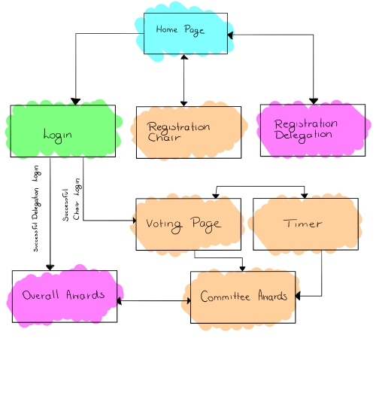

### 

### Home page

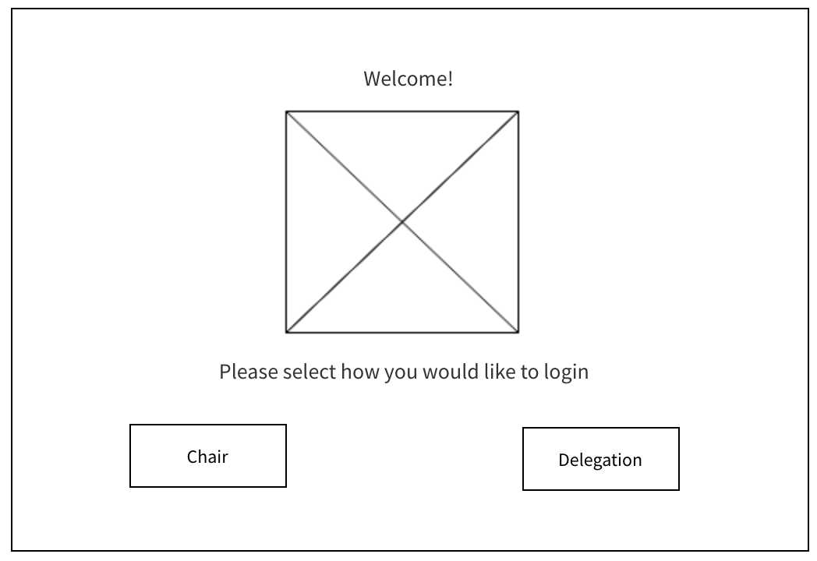

Stage 1: The user selects how they want to use the program; either viewing the results as a delegate or as a chair. They will select the button of whether they are a delegate or a chair.

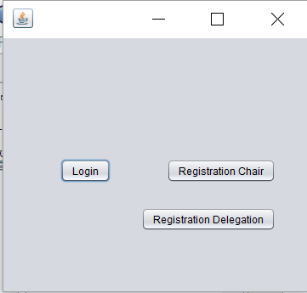

Stage 2: I decided to change the whole concept of the home page. There will be a single login for both the chair and the delegation and therefore only a login button is needed. I realised that I needed a registration button and so included this in the home page. I was going to have a single registration button however since both the registrations were so different I decided just to have separate registration pages and so there are separate buttons to take the user to either the chair registration or the delegation registration.

### 

### Login

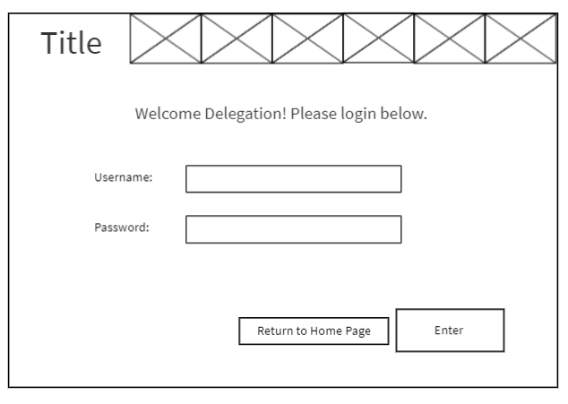

Stage 1: There will be a separate login for both the Delegation and the Chair. The delegate will get a delegation login and inputs their username and password. Once the username and password are entered the user will have to click the enter button. Once this happens the username and password are validated to make sure they match the usernames in the database. If the username and passwords match and exist then they will be able to move on however if they don’t then an error message will appear and they won’t be able to progress from the login page. There will also be a ‘return to home page’ button in which when it is pressed it take the user to the home page.

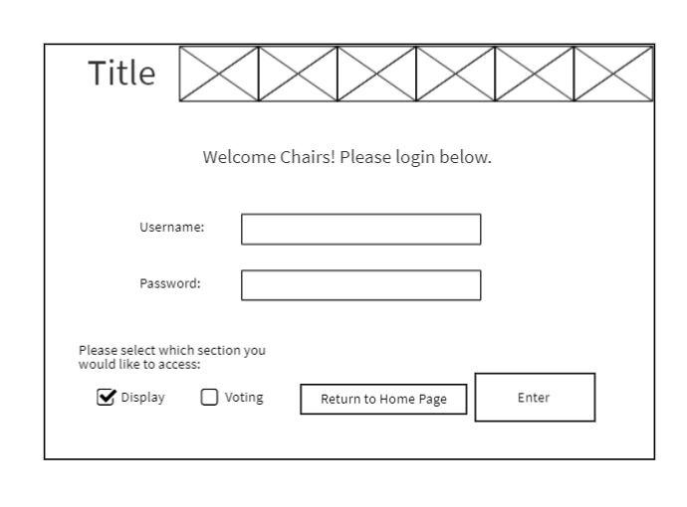

The chair login will work in a similar way to the delegation login however as well as entering the username and password the chair will also interact with a checkbox and click whether they want the timer option (display) or the voting page.

Stage 2: Instead of having two separate login pages I thought it would be more efficient just to have a single login page and that depending on the username and password entered the program automatically knows whether the user is a chair or a delegation and will take the user to the according page.

The login page is very simple and not busy so that it is easy to use and not distracting. The user will type in the username into the username box and will type the password into the password box. The password box is protected as anything typed into the box appears as asterisk (*) and therefore increases the security of the application. Once the username and password is entered the user can press the enter button to which if the login is successful the user will be taken to the corresponding page and if unsuccessful an error message will appear and the user will have another opportunity to enter the username and password again.

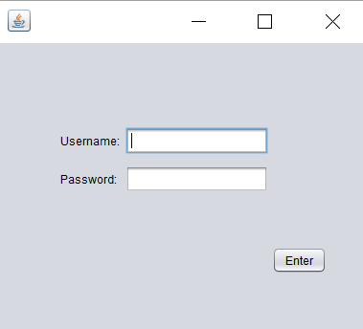

### 

### Voting

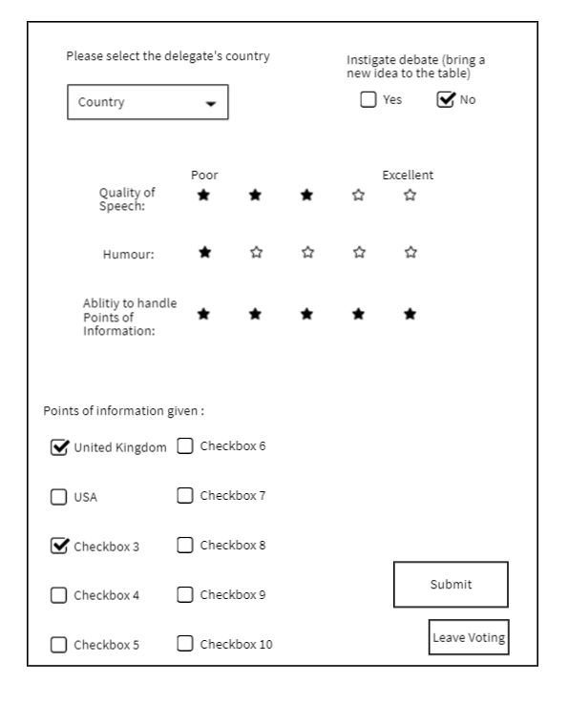

Stage 1: The chairs will interact with this page during the conference. The chairs will be able to select which country is speaking from and the information about quality of speech, humour and ability to handle points of information will be recorded for that person. During my survey a quality which was suggested was whether or not that delegate instigated the debate. If they did extra points would be rewarded.

If delegates give a point of information then this will be noted by the chairs through the use of checkboxes. This will then hold some weight when calculating a delegates overall score.

After the main delegate who is speaking finishes the chairs can submit their voting forms and this will clear the form for a new one. When the chair presses the ‘leave voting’ button a message will appear asking what page they would like to go to: the display section or back to the homepage.

Stage 2: This is a partially completed voting form that has the basic structures of what the form will look like in a high fidelity wireframe. There is a drop down list in which the chair will be able to select the country that is speaking and who the voting form is about. This is a drop down list so that there is no misspelling on any countries name (a feature that would cause a problem especially when retrieving results from a database). This drop down list will change automatically depending on which countries are in the committee (security council doesn’t have all the countries) and which new countries register.

There are slider bars which allows the chair to vote on the aspects of: quality of speech, humour in speech and ability to handle points of information. The slider bars automatically ‘snap’ to the nearest whole number and so this will be easy for the chair to do in a fast pace environment like an MUN conference and this will make the voting process much easier.

There is a checkbox titled ‘added new information to debate’ which if clicked will add more points to the delegates total score. This was put in a checkbox as its just a ‘yes or no’ response.

There is a section for countries who gave points of information and the chairs can then just select the countries from the list if those countries gave a point of information to the speaker.

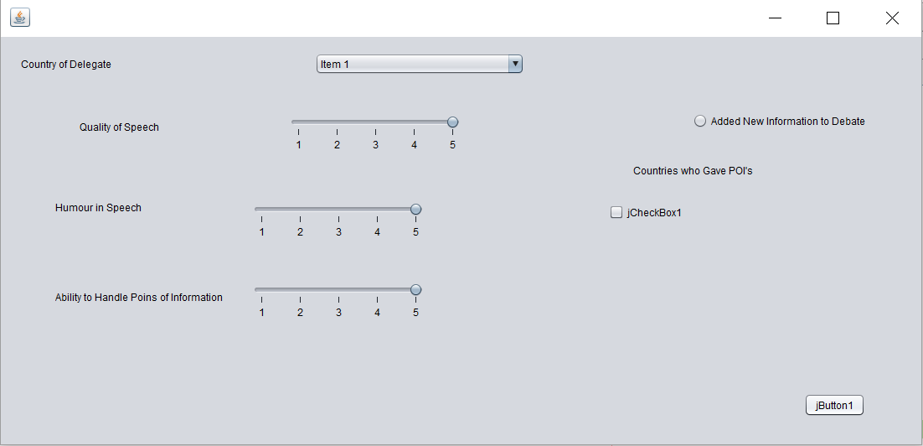

Stage 3: Not much has changed since the here and the stage 2 however I have just cleaned up and finished the design more (colours and overall design aesthetically still has to be improved). I decided to remove the checkboxes of the countries who gave point of information feature as this would have cluttered up the voting form and I felt this feature wasn’t important so removed this.

I included a button that would submit the voting form and once this button is pressed then a message will appear either saying ‘successful’ or ‘unsuccessful’ depending whether or not the form has been successfully submitted into the database.

If the timer button is pressed then the user will be taken to the timer page and the voting form will close. If the awards page button is clicked then the user will be taken to the awards committee page and the voting form will close.

## 

## 

## 

## Results

This will contain the output and rankings of all committees as well as the overall ranking of the delegation and all the rewards will also be present. As well as that country (who logged in) individual scores in their committee. The delegates will be able to view their ranking as a delegation as a whole, view their ranking in the committee as a whole and they will be able to access and view their own individual breakdown scores. The chairs will be able to view the rankings of all the delegations, view their committees ranking and view all the individual breakdowns in their committee.

## 

## Persona

**Name:** Sarah Smart

**User Type:** Chair

**Committee:** Disarmament

**Country:** N/A

**Background:** This is Sarah’s first time chairing a debate. She wants to use this system to help her with the timing of the debate and to make sure it runs smoothly. Since this is Sarah’s first time chairing a debate she is unsure how she should rank delegates and what qualities qualify for a prize. The system will help guide Sarah through this as it tells her about specific aspects she should vote on.

**Name:** Alexander Walker

**User Type:** Delegate

**Committee:** EdSiCul (Education, Science and Culture)

**Country:** France

**Background:** Alexander is a very experienced delegate and knows how MUN conferences work. Alexander finds the screen that is displayed to delegates very useful as he can see how much time he has to talk. In previous conferences he has attended he found the use of a computer system useful to make sure the discussions stay on track. Alexander is always worried in conferences that the chairs will pick someone for the Best Delegate Award because they know them personally and not due to their MUNing ability. This is why Alexander is looking forward to the use of the voting system for the chairs.

## Scenarios

### Login Delegates

**Actor:** Delegate

**Scenario:** When the program loads they will be taken to the Home Screen(as shown in the wireframes). They will then press a button to select to go to the delegation login. They will then put in their respective username and password into the input boxes. After they finish inputting the data they will press the submit button. Input validation will then be required by the system to make sure the passwords and usernames match the ones in the database and have the correct access rights and if the usernames and password matches they will be able to continue.

### Login Chairs

**Actor:** Chairs

**Scenario:** When the program loads they will be taken to the Home Screen(as shown in the wireframes). They will then press a button to select to go to the chairs login. They will then put in their respective username and password into the input boxes. The chairs during their login will also have to select which page they would like to go to (voting or display); this will be done by selecting a button. After they finish inputting the data they will press the submit button. Input validation will then be required by the system to make sure the passwords and usernames match the ones in the database and have the correct access rights and if the usernames and password matches they will be able to continue.

### Vote on delegates

**Actor:** Chair

**Scenario:** The chair uses the voting form to input the data about the delegate who is currently speaking.The form is then submitted and values are added to any existing score (running total for all the different categories). These scores are held in a database.

### Timer

**Actor:** Chair

**Scenario:** The chair can select the length of the timer and speaker timer they want and can name the timer (i.e ‘Time for amendment’). They can then select from the list of countries for countries who wish to speak. When the click the play button the timer for the first country will begin. Throughout a pause and play button can be clicked on for when points of information are asked. If the delegate hands back over to the chair before the timer is done the chair can click the finished button and the timer will reset to the next country.

### View Results Delegates

**Actor:** Delegate

**Scenario:** The delegates can use the password provided to the school and look at the rankings compared to all other schools for the committees as a whole. They will also be able to view any awards given. The delegate can look at any of their delegations individual scores ubt won’t be able to see any other delegations individual scores they will however be able to see where they are ranked against other delegations. This area is mainly just for viewing and the Delegate will mainly interact through buttons or hyperlinks to get to new areas.

### View Results Chairs

**Actor:** Chair

**Scenario:** The chairs can choose to go to the results page in which they will be able to view the results for all the delegations as a whole and the overall best delegation award. The chairs will only be able to view their committees result and see all the delegates in their committees individual breakdowns and rankings. They will also be able to see the awards in their own committees.

## User Centric Design - Use Case Diagrams

*Stage 1 before the implementation of my application*

## 

## 

## 

## Class Diagram

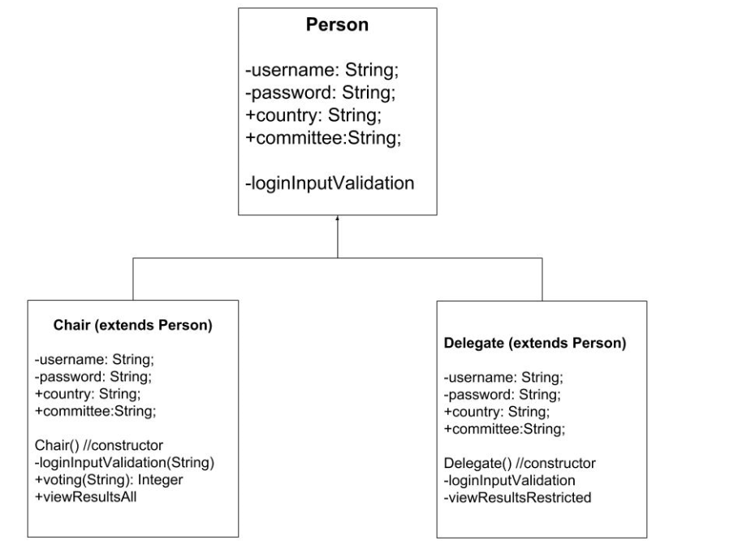

## 

## Conceptual Model

### Login

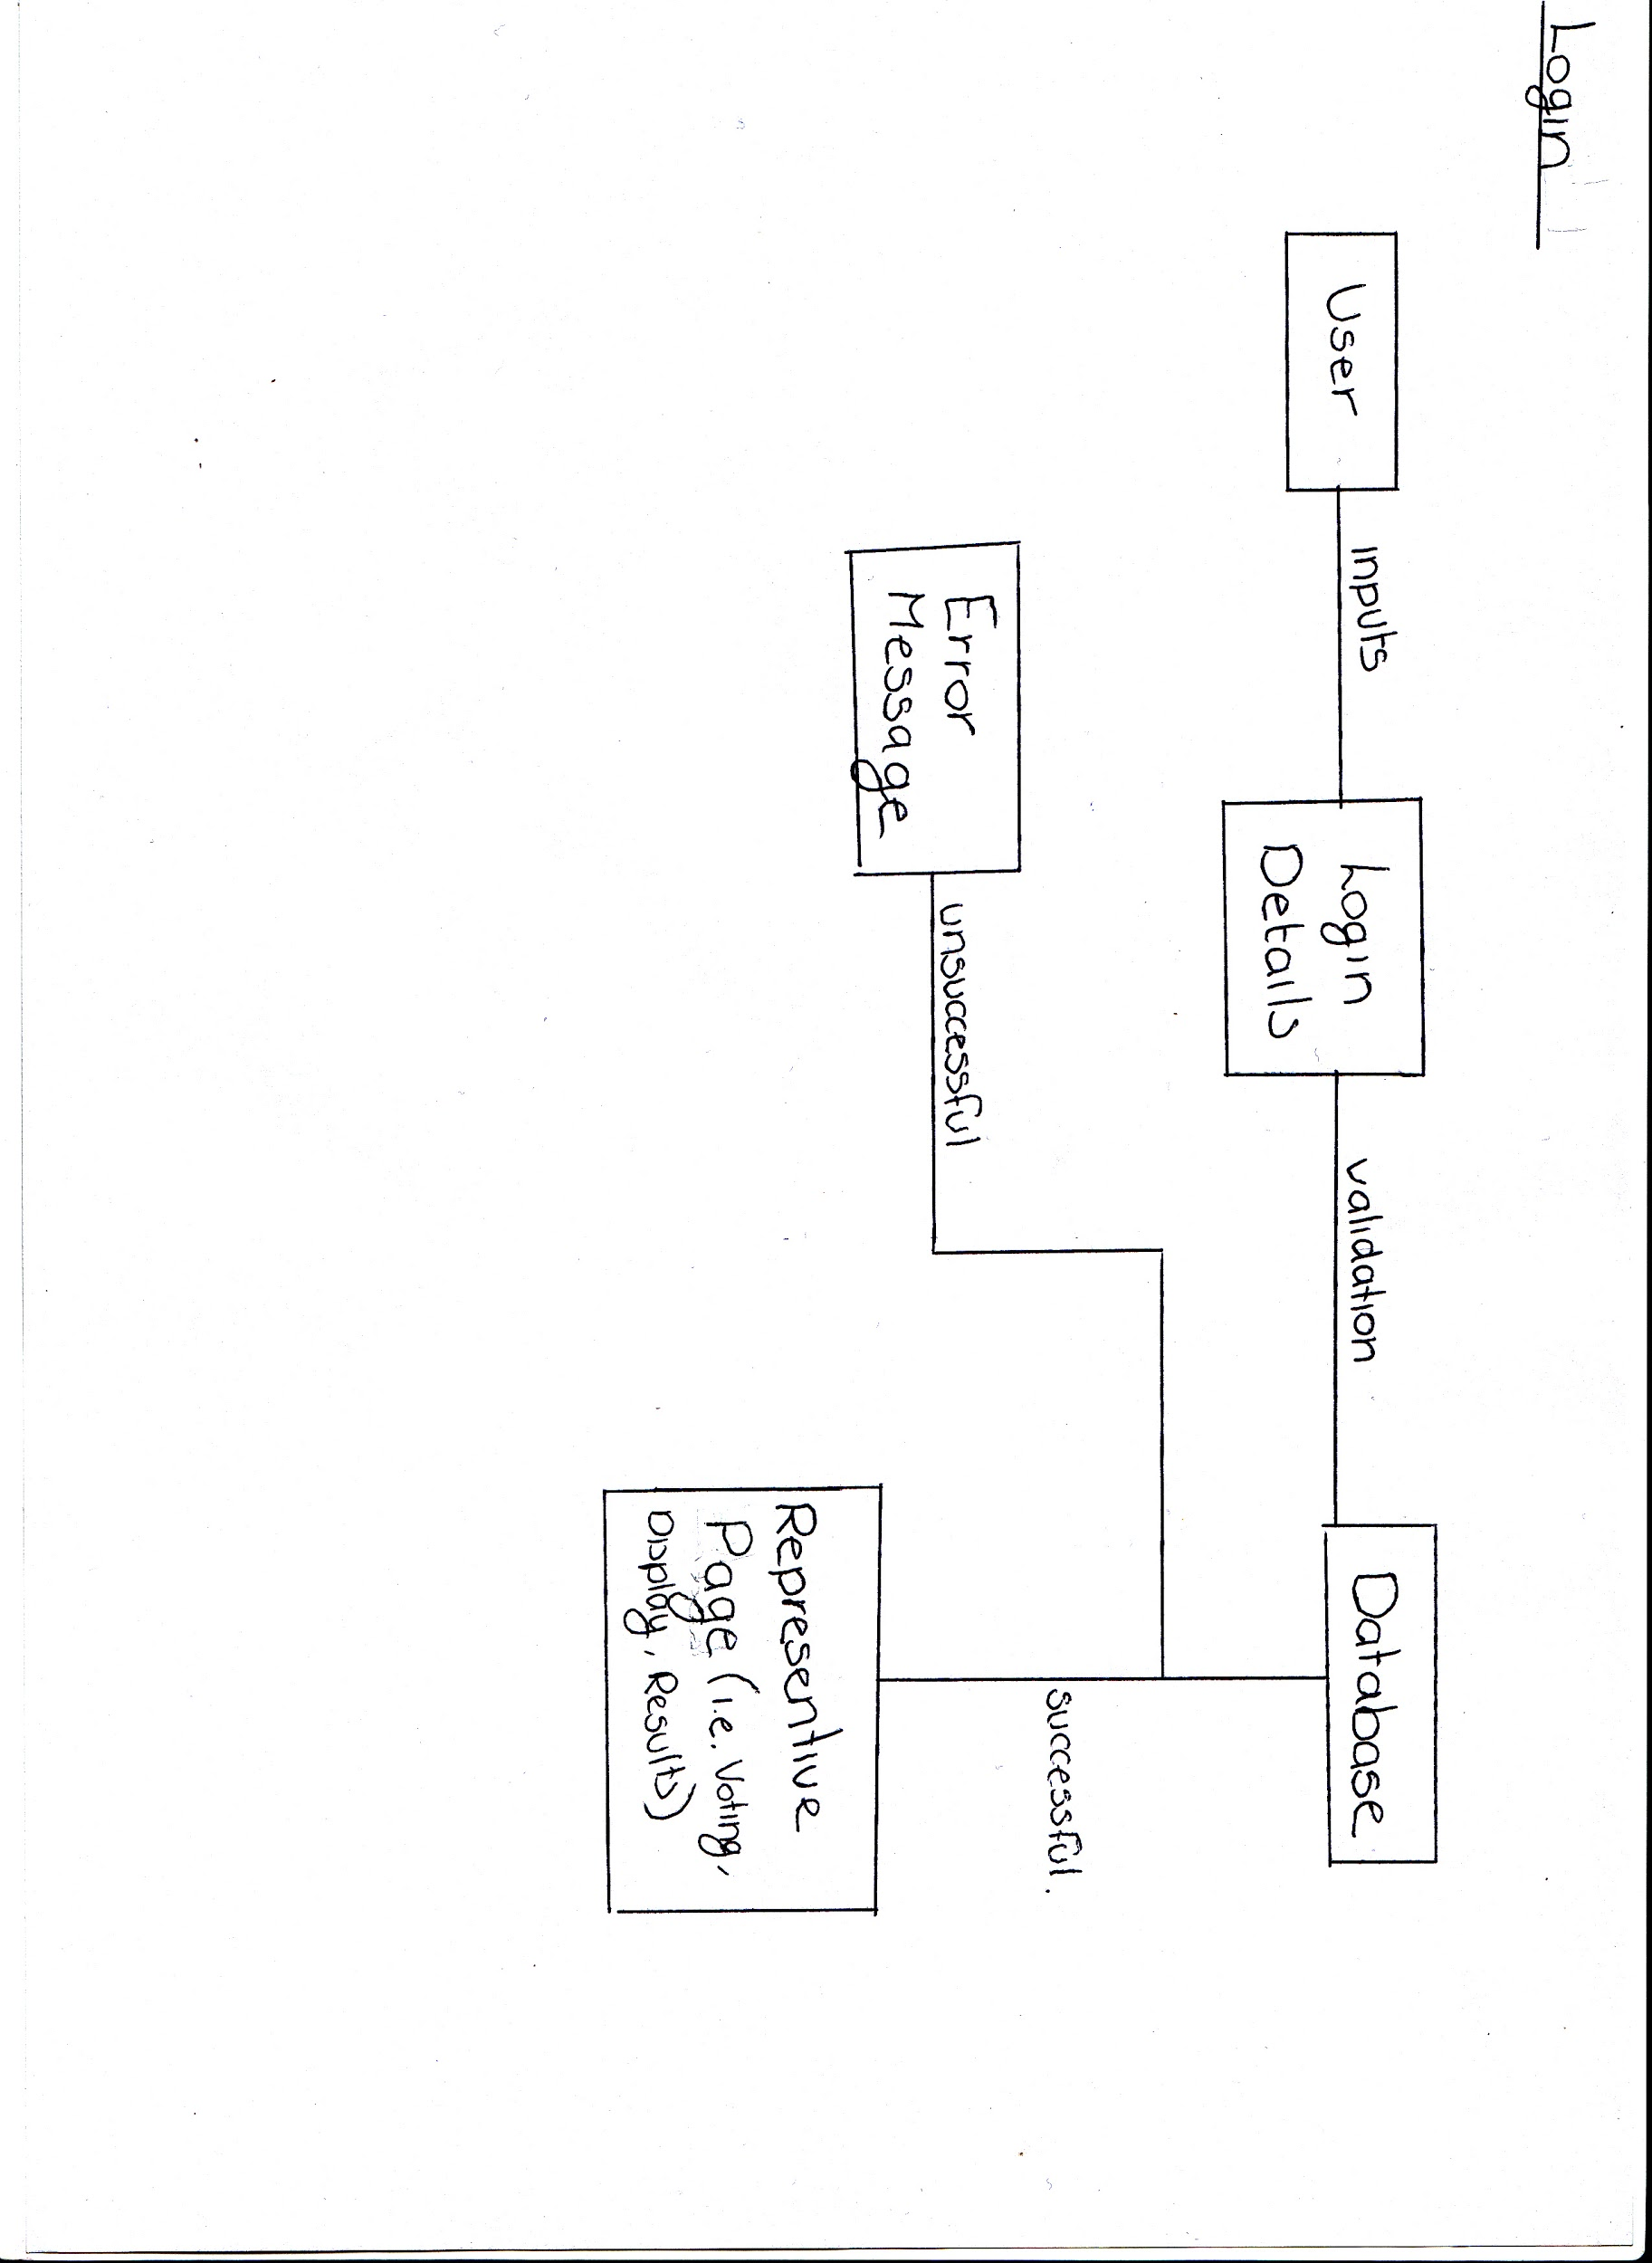

### Display

### 

### Voting

### 

### 

### 

### 

### 

### 

### 

### 

### 

### Results

### 

## Sequence Diagram

### Login

### *Stage One*

### 

*Stage Two*

## Timer

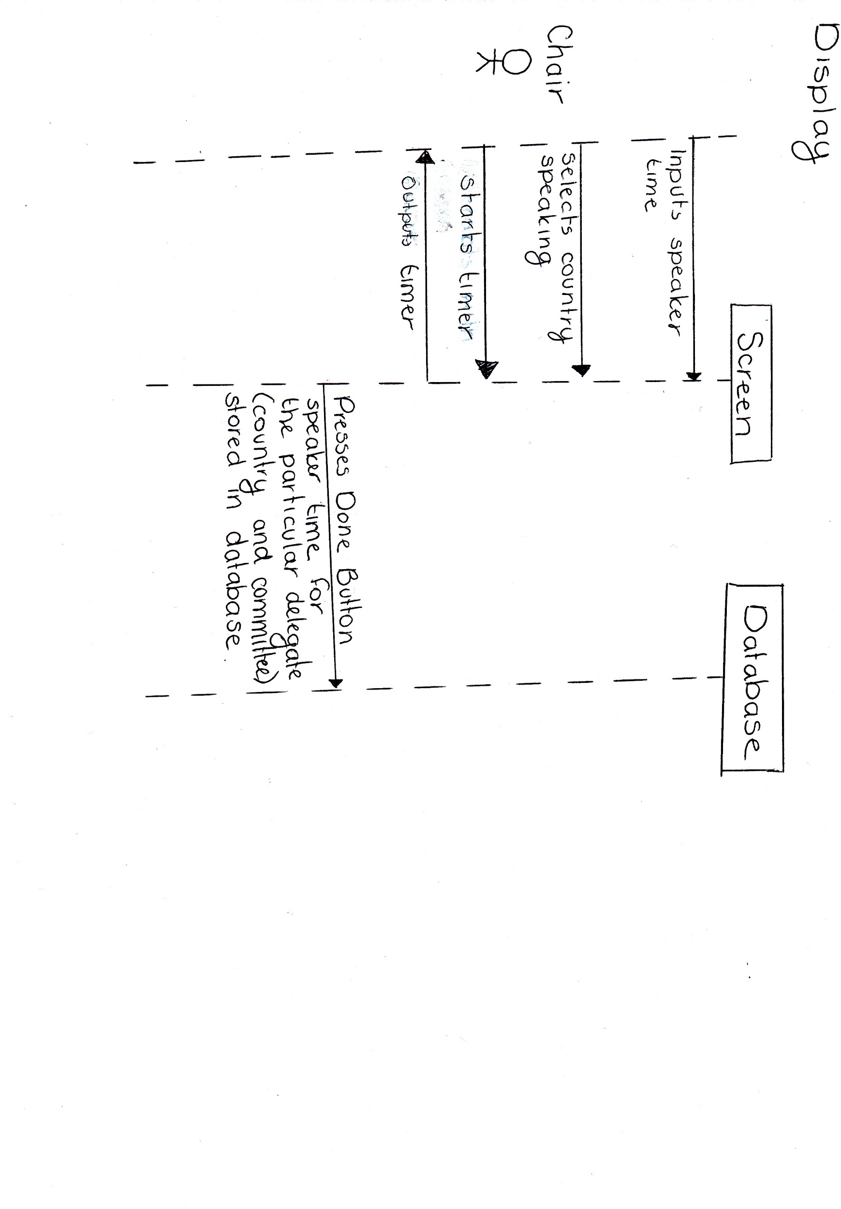

### 

### Voting

### Results

## Data Dictionary

Stage 1: This was designed before the implementation of my program so a lot had changed once I started implementation.

|  |  |  |  |  |  |  |  |
| --- | --- | --- | --- | --- | --- | --- | --- |
| Name of Field | Data Type | Data Size  (byte) | Key (if any which type?) | Unique  (Y/N) | Required (Y/N) | Validation | Sample Data |
| **Delegate** | | | | | | | |
| DelegateID | Auto Number | 8 | Primary | Y | Y |  | 1 |
| username | String | 100 |  | N | Y |  | MegzGal2 |
| password | String | 100 | - | N | Y | Must be between 6 and 12 characters and include a capital letter, symbol and number. | pass4Word |
| age | Integer | 8 |  | N | Y | Between 12 and 30 | 16 |
| country | String | 50 |  | N | N |  | Israel |
| committeeID* | Auto Number | 8 | Foreign | N | Y | Auto Lookup from Committees table | 5 |
| totalScore | Integer | 50 |  | N | N |  | 100 |
| **Chair** | | | | | | | |
| ChairID | Auto Number | 8 | Primary | Y | Y |  | 1 |
| username | String | 100 |  | Y | Y |  | CoolChair5 |
| password | String | 100 |  | N | Y | Must be between 6 and 12 characters and include a capital letter, symbol and number. | pass4Word |
| committeeID* | Auto Number | 8 | Foreign | N | Y | Auto Lookup from Committees table | 5 |
| **Voting** | | | | | | | |
| DelegateID* | Auto Number | 8 | Primary and  Foreign | N | Y | Auto Lookup from Delegates table | Israel |
| qualityScore | Integer | 50 |  | N | N | Between 1 and 5 | 5 |
| humourScore | Integer | 50 |  | N | N | Between 1 and 5 | 2 |
| abilityPOIScore | Integer | 50 |  | N | N | Between 1 and 5 | 3 |
| instagateDebate | Boolean | 50 |  | N | Y |  | Yes |
| timeSpoken(min) | Real Number | 50 |  | N | N |  | 23 mins |
| **Committee** | | | | | | | |
| committeeName | String | 50 | Primary | N | Y |  | DISEC |
| ChairsID* | Auto Number | 8 | Foreign | Y | Y | Auto Lookup from Chairs table | 1C |
| DelegateID* | Auto Number | 8 | Foreign | Y | Y | Auto Lookup from Delegates table | ID |

## 

Stage 2: This data dictionary was created after the implementation so that all the actual implemented database could match the data dictionary. There were some small changes on what type of data values were used for example ‘VarChar’ was used instead of ‘String’ this was due to the fact that in phpMyAdmin it was more reliable to use this data type.

## 

## 

## Entity Relationship Diagram

Stage 1: This was created and designed before the implementation of my program. I thought through what I wanted my program to do and how I wanted to achieve my ideas and so came up with this database to store all my data.

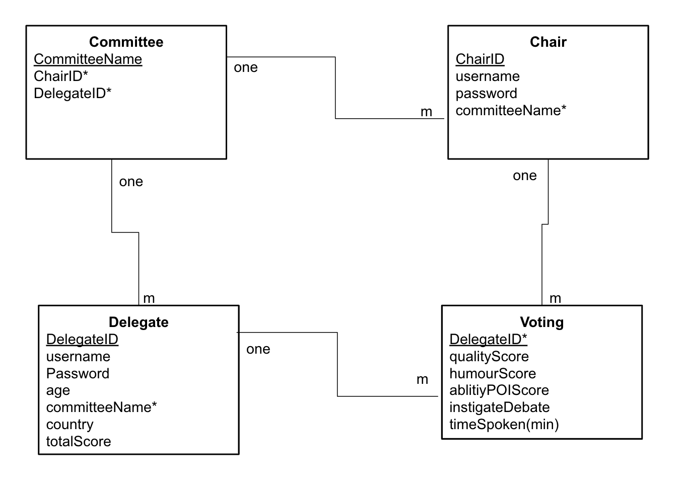

many

many

many

many

Stage 2: After the implementation of my database and throughout the implementation of my program I realised that I needed more tables and different connections.I realised this once I started creating my program and thinking more about how I would achieve tasks. This was particularly true whenever I needed to use SQL statements to read from the database and whether I could get the information I desired from the database correctly.

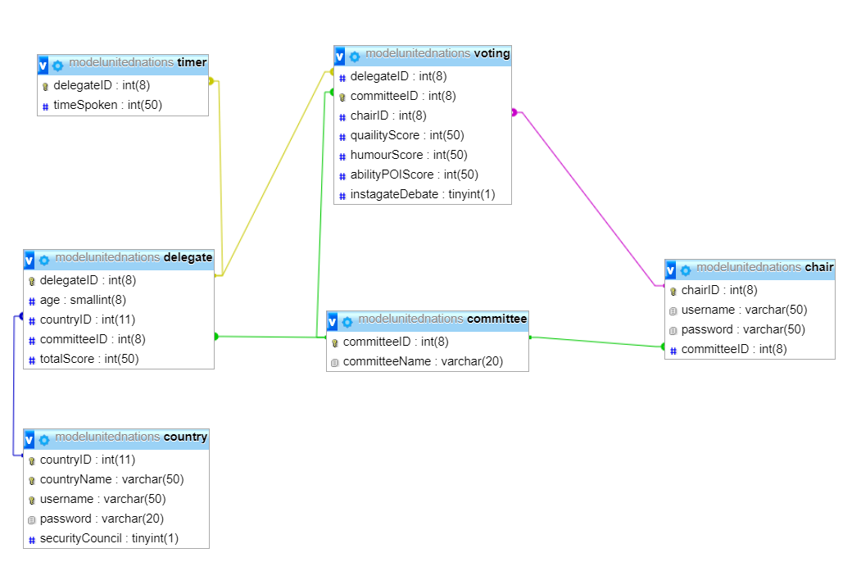

# 

# 

Stage 3: My database changed very slightly again because I encountered a problem in the code and realised that I had made a mistake in the voting table. I realised I had made the *‘committeeID’* field a primary key when I hadn’t meant to. This was then fixed and changed.

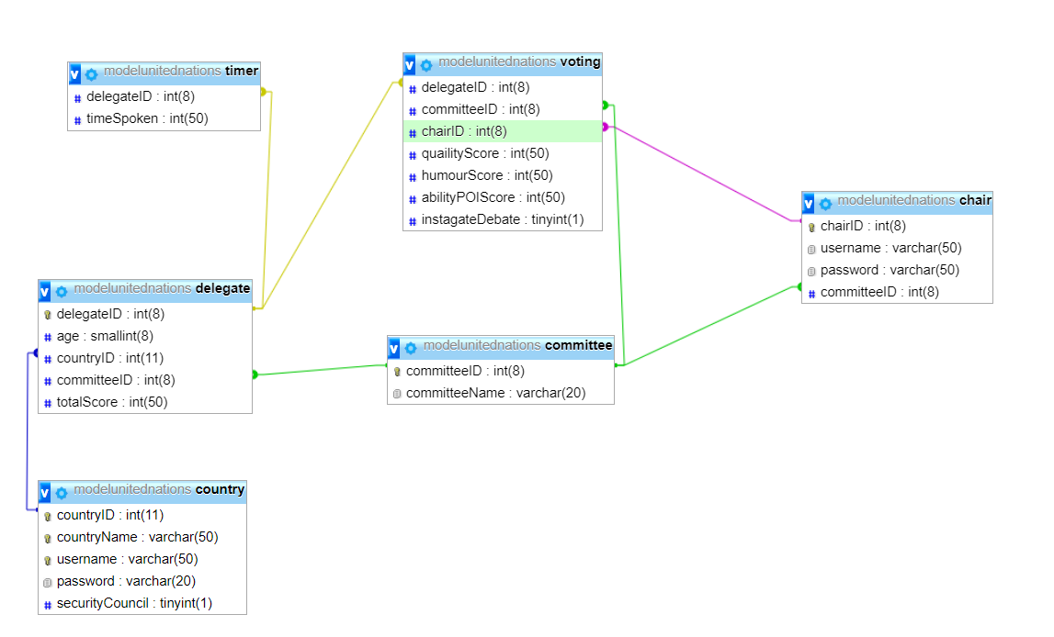

# 

## Pseudocode

1. Home Page
2. Login Page
3. Chair Registration
4. Delegation Registration
5. Voting
6. Timer
7. Awards Committee
8. Awards Overall

# Implementation

## Database

### SQL Statements To Create Table

*CREATE TABLE chair (*

*chairID INT(8) NOT NULL AUTO_INCREMENT PRIMARY KEY,*

*username VARCHAR(50) NOT NULL,*

*password VARCHAR(50) NOT NULL,*

*CONSTRAINT committeeID FOREIGN KEY(committee),*

*CONSTRAINT delegateID FOREIGN KEY(delegate)*

*)ENGINE=InnoDB DEFAULT CHARSET=latin1;;*

*CREATE TABLE committee (*

*committeeID INT(8) NOT NULL AUTO_INCREMENT PRIMARY KEY,*

*committeeName VARCHAR(20) NOT NULL*

*)ENGINE=InnoDB DEFAULT CHARSET=latin1;;*

*CREATE TABLE country (*

*countryID INT(11) NOT NULL AUTO_INCREMENT PRIMARY KEY,*

*countryName VARCHAR(50) NOT NULL,*

*username VARCHAR(50) NOT NULL,*

*password VARCHAR(20) NOT NULL,*

*securityCouncil TINYINT(1) NOT NULL*

*) ENGINE=InnoDB DEFAULT CHARSET=latin1;*

*CREATE TABLE delegate (*

*delegateID INT(8) NOT NULL AUTO_INCREMENT PRIMARY KEY,*

*age SMALLINT(8) NOT NULL,*

*countryID INT(11) NOT NULL,*

*committeeID INT(8) NOT NULL FOREIGN KEY(committee),*

*totalScore INT(50) NOT NULL*

*) ENGINE=InnoDB DEFAULT CHARSET=latin1;*

*CREATE TABLE timer (*

*delegateID INT(8) NOT NULL FOREIGN KEY(delegate),*

*timeSpoken INT(50) NOT NULL*

*) ENGINE=InnoDB DEFAULT CHARSET=latin1;*

*CREATE TABLE voting (*

*delegateID INT(8) NOT NULL FOREIGN KEY(delegate),*

*committeeID INT(8) NOT NULL FOREIGN KEY(committee),*

*chairID INT(8) NOT NULL FOREIGN KEY(chair),*

*quailityScore INT(50) NOT NULL,*

*humourScore INT(50) NOT NULL,*

*abilityPOIScore INT(50) NOT NULL,*

*instagateDebate TINYINT(1) NOT NULL*

*) ENGINE=InnoDB DEFAULT CHARSET=latin1;*

### 

### SQL Statements To Insert Values

INSERT INTO `chair` (`chairID`, `username`, `password`, `committeeID`) VALUES

(2, 'Andrew', 'AndyPass', 1);

INSERT INTO `committee` (`committeeID`, `committeeName`) VALUES

(1, 'Disarmament');

INSERT INTO `country` (`countryID`, `countryName`, `username`, `password`, `securityCouncil`) VALUES (19, 'United States of America', 'Megz', 'Password1', 1);

INSERT INTO `delegate` (`delegateID`, `age`, `countryID`, `committeeID`, `totalScore`) VALUES

(2, 17, 19, 1, 0);

INSERT INTO `voting` (`delegateID`, `committeeID`, `chairID`, `quailityScore`, `humourScore`, `abilityPOIScore`, `instagateDebate`) VALUES

(6, 1, 2, 5, 5, 2, 0);

### SQL Statements In Program

# 

# 

## Java

### Connection

During the implementation of my program I realised I would need to connect my program to database so that the information stored on the database could be reflected in my program. This criteria was not apart of the *Advanced Higher Computing Science* course so a lot of research was done to complete a connection.

A diagram for what the connection to a database looks like can be shown in the diagram below:

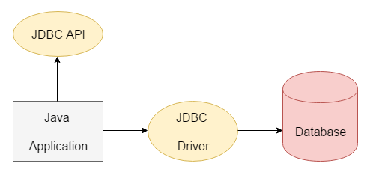

When creating a connection to a database you need to realise that in order for the database on phpMyAdmin to communicate with the program you would need to make use of the *JDBC* functions. *JDBC* stands for ‘Java Database Connectivity’.[13] *JDBC* is a type of *Java API* that allows you to connect and interact with the database. A *Java API* is a shorthand for *Java Application Programming Interface*. The *Java API* is just predefined classes and functions that have already been tested that are already pre-installed or downloaded onto *Java Netbeans* .

When connecting to the database there are two main requirements needed: *JDBC API* and *JDBC Driver*. The *JDBC API* is used specifically for accessing tabular data that is stored in relational databases. The use of *JDBC API* means that data can be added, updated, deleted or fetched from the database. The *JDBC Driver* is the software component which allows the java application to directly interact with a database. A certain driver named *MySQL* was used in my database as I was interacting with my database using SQL statements.

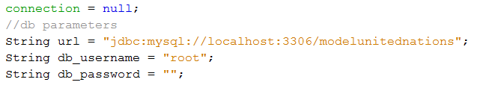

Above is a line of my code which shows the url for my database. It can be seen that the use of the *JDBC* function is being used.

In some applications a *JDBC DriverManager* can be used. A *DriverManager* just manages any different drivers that are being used. This was an unnecessary addition as I only had an interaction with one database and therefore only a driver was necessary to complete my application’s database connection however I also ended up using a *DriverManager* incase I needed to use the connection for other databases as well.



Above is a line of my code which shows how I have used the DriverManager to get a connection to my database.

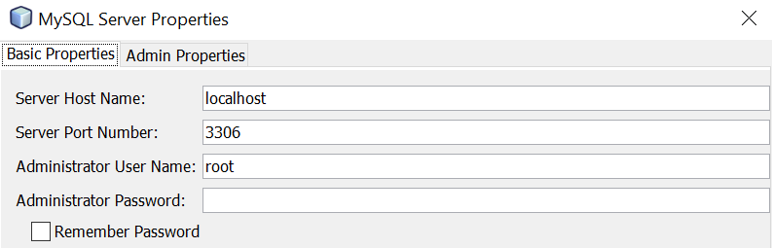

When setting up the connection I needed to make sure that the server I was using to host the database was connected and so I needed I went to the server settings of *Java Netbeans* and inputted the information shown on the form to the right. The information for the server was all found on *Xampp* and also found on *phpMyAdmin*.

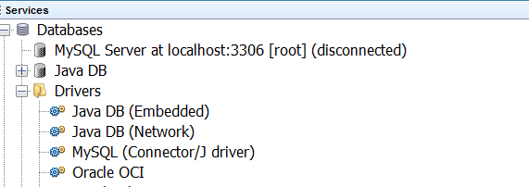

In my application you can see how I have needed select the server I am working with and how I am interacting with it (MySQL) and it can be seen that there is a connection made with the database, there is only a disconnection currently as the server I am running my computer on hasn’t started. It can also be seen how I have made use of the Drivers so as to create the connection to the database.

Since I knew I wanted to make use of my connection multiple times throughout the program, to increase efficiency, I created a class for the connection of the database and then then had a subclass of the connection being made and then an accessor which would be used to access the connection so as this connection variable could be used in other modules of code throughout the program.

# Testing

## Home Page

* Login button when pressed should take you to the login page
  + Yes, performs as expected
* Registration Delegation button when pressed should take you to the registration delegation page
  + Yes, performs as expected
* Chair Delegation button when pressed should take you to the registration chair page
  + Yes, performs as expected

# 

## 

## Login Page

* If username and password of Chair is entered correctly then the user should be prompted with a message saying ‘Welcome Chair’

|  |  |  |  |
| --- | --- | --- | --- |
| Input Screenshot | Username  Password | Expected Result | Output Screenshot |
|  | Andrew  AndyPass | Login Successful message |  |

* If username and password of Delegation is entered correctly then the user should be prompted with a message saying ‘Welcome delegate’

|  |  |  |  |
| --- | --- | --- | --- |
| Input Screenshot | Username  Password | Expected Result | Output Screenshot |
|  | Megz  Password1 | Login Successful |  |

* If username and password do not match then an error message asking to re-input username and password will be displayed.

|  |  |  |  |
| --- | --- | --- | --- |
| Input Screenshot | Username  Password | Expected Result | Output Screenshot |
|  | WrongUsername  Pass | Neither the username or password are values within the database and so login should be unsuccessful |  |
|  | Andrew  Pass | The username is an actual username however the password doesn’t match and so the login should be unsuccessful. |  |
|  | A  AndyPass | The password is an actual password however the username doesn’t match and so the login should be unsuccessful. |  |
|  | Andrew  PassWord | The username and password are both actual values in the database however they don’t belong to the same instance therefore the login should be unsuccessful. |  |

* If one or both of the fields (username and password) are left empty but the enter button is pressed then the user will be prompted to make sure to fill in all the fields.

|  |  |  |  |
| --- | --- | --- | --- |
| Input Screenshot | Username  Password | Expected Result | Output Screenshot |
|  | Blank  Blank | Error Message followed by a login unsuccessful message |  |
|  | Andrew  Blank | Error Message followed by a login unsuccessful message |  |
|  | Blank  PassWord | Error Message followed by a login unsuccessful message |  |

* If login is successful then the user is brought to the corresponding page
  + Successful Chair login is brought to the voting or timer page
    - * Yes, performs as expected
  + Successful Delegation login is brought ot the leaderboard page

# 

# 

# 

# References

<http://bestdelegate.com/4-useful-apps-for-model-un-students/>

<https://www.munplanet.com/questions/mun-technology/what-is-the-best-software-to-run-a-model-united-nations-committee>

<https://www.techwalla.com/articles/the-advantages-disadvantages-of-visual-basic>

<https://netbeans.org/switch/why.html>

<http://infotech101.com/the-netbeans-ide-pros-cons/>

<https://www.siteground.com/tutorials/php-mysql/mysql/>

<https://www.tutorialspoint.com/What-are-the-advantages-and-disadvantages-of-using-MySQL-stored-procedures>

<https://www.techwalla.com/articles/the-advantages-of-oracle-databases>

1. <https://www.tomshardware.co.uk/Intel-Xeon-Eco-friendly,news-29117.html>
2. <https://greendiary.com/7-eco-friendly-computer-concepts-show-greener-side-technology.html>
3. <http://bestdelegate.com/4-useful-apps-for-model-un-students/>
4. <https://www.munplanet.com/questions/mun-technology/what-is-the-best-software-to-run-a-model-united-nations-committee>
5. <https://www.munplanet.com/questions/mun-technology/what-is-the-best-software-to-run-a-model-united-nations-committee>
6. <https://techterms.com/definition/java>
7. <https://www.mindsmapped.com/java-advantages-and-disadvantages/>
8.
9. <http://lavape.sourceforge.net/doc/html/AdvantVB.htm>
10. <https://www.techwalla.com/articles/the-advantages-disadvantages-of-visual-basic>
11. <http://infotech101.com/the-netbeans-ide-pros-cons/>
12. <https://www.trustradius.com/products/visual-studio-ide/reviews/pros-and-cons?f=25>
13. <https://www.javatpoint.com/java-jdbc>

    Image: <https://www.javatpoint.com/java-jdbc>